NAME : Arnav Upperwal
SAP ID :590027436
SUBJECT:PYTHON LAB
EXPERIMENT :1

- Install Python and write the steps of installation and understand difference between scripting and interactive modes in IDLE.
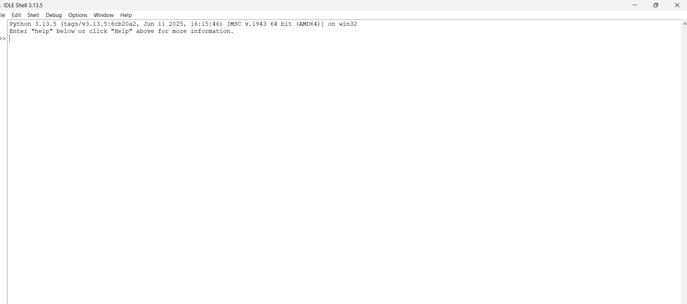

2. Create a variable to store your age and print its type using type ().
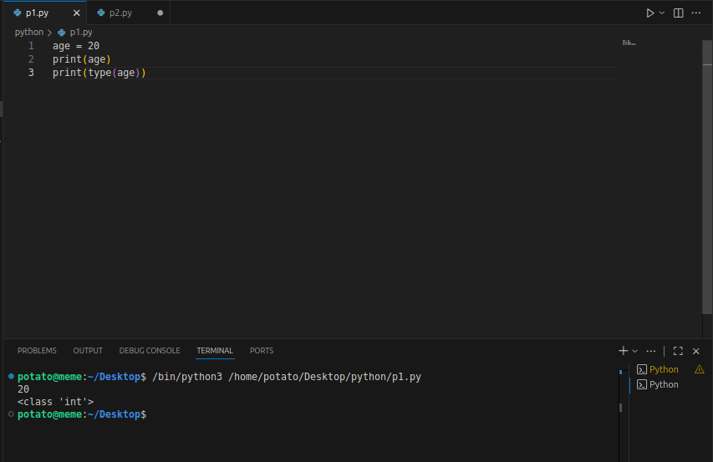
3. Declare a string variable called x and assign it the value “Hello”. a. Print out the value of x
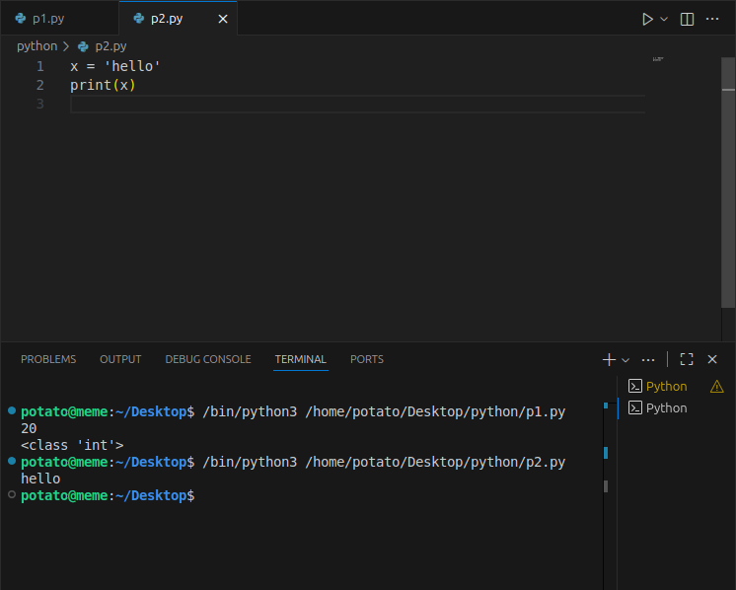
4. Take different data types and print values using print function.
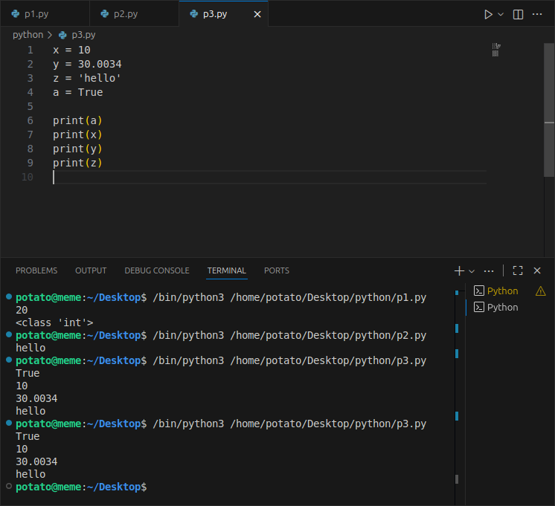
5. Declare these variables (x, y and z) as integers. Assign a value of 9 to x, Assign a value of 7 to y, perform addition, multiplication, division and subtraction on these two variables and Print out the result.
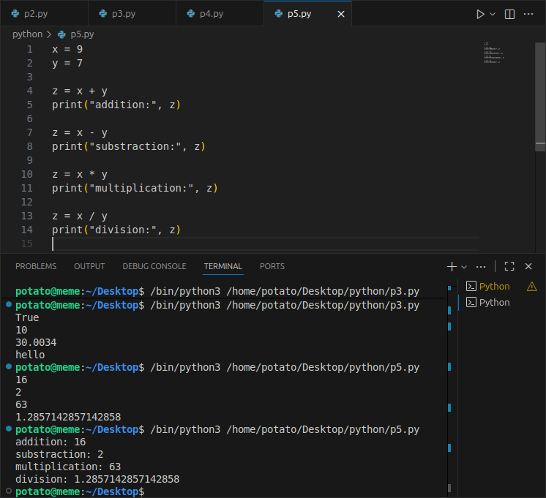
6. Write a program to compute the length of the hypotenuse (c) of a right triangle using Pythagoras theorem.
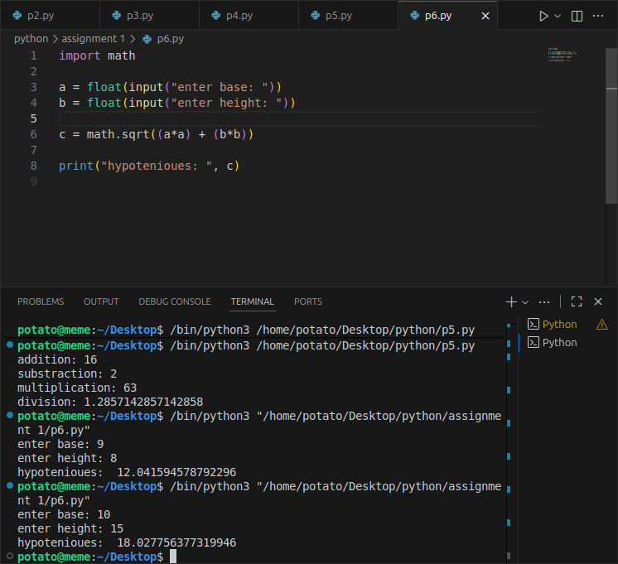
7. Write a program to find simple interest.
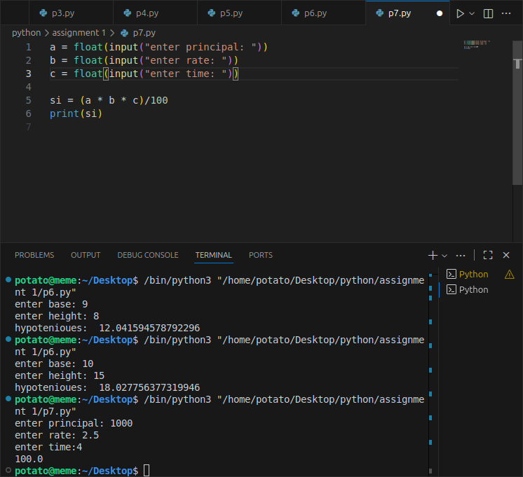
8. Write a program to find area of triangle when length of sides are given.
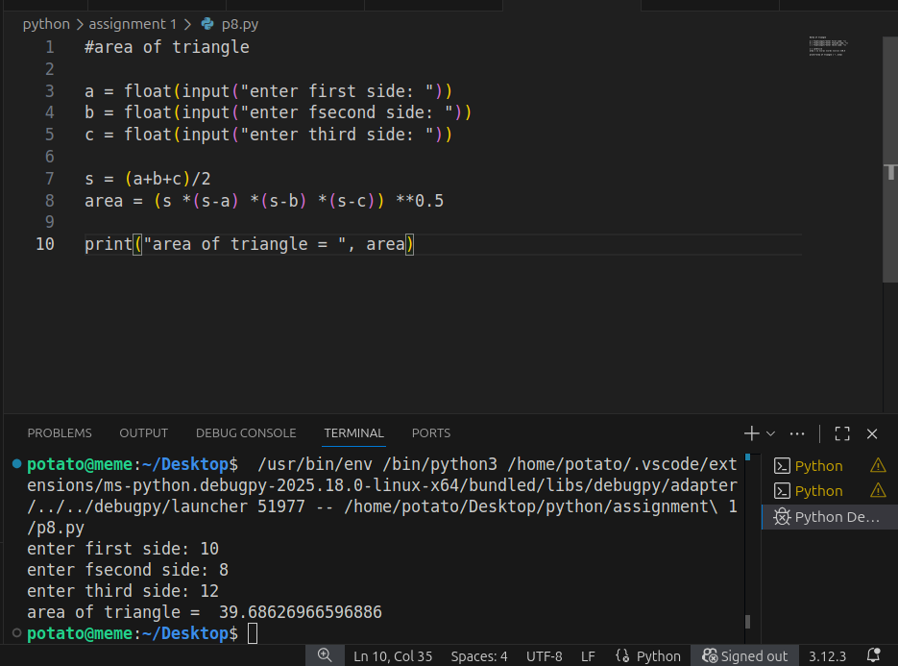
9. Write a program to convert given seconds into hours, minutes and remaining seconds.
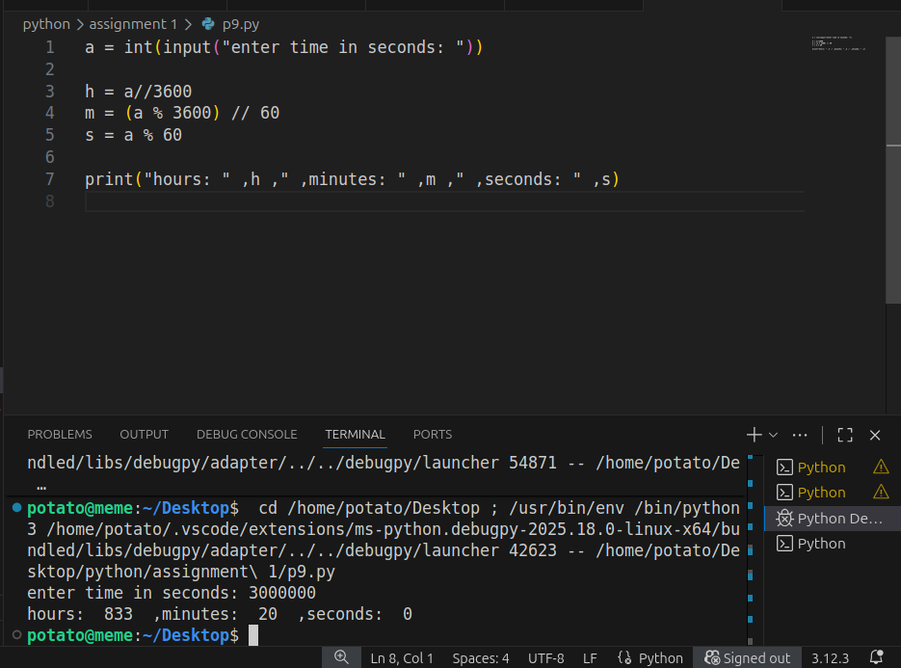
10. Write a program to swap two numbers without taking additional variable.
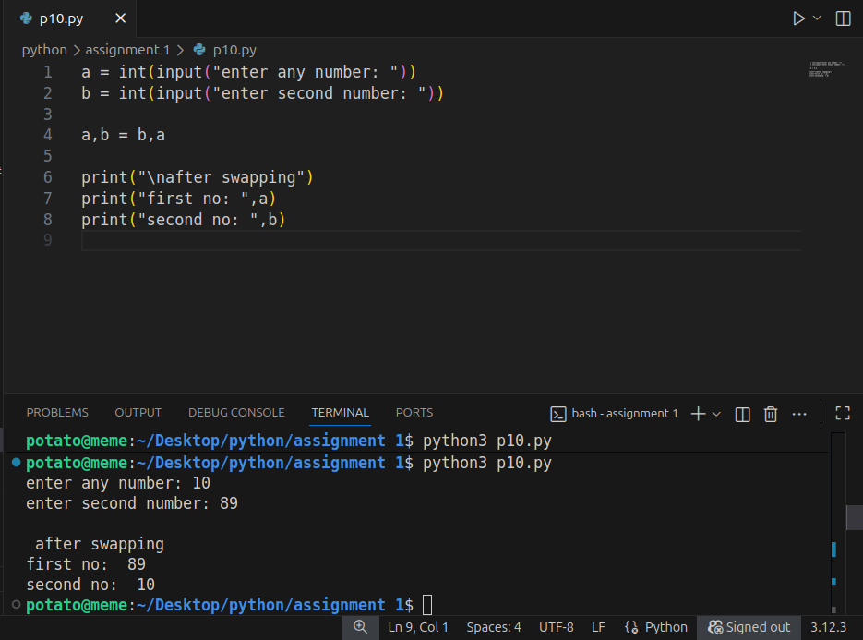
11. Write a program to find sum of first n natural numbers.
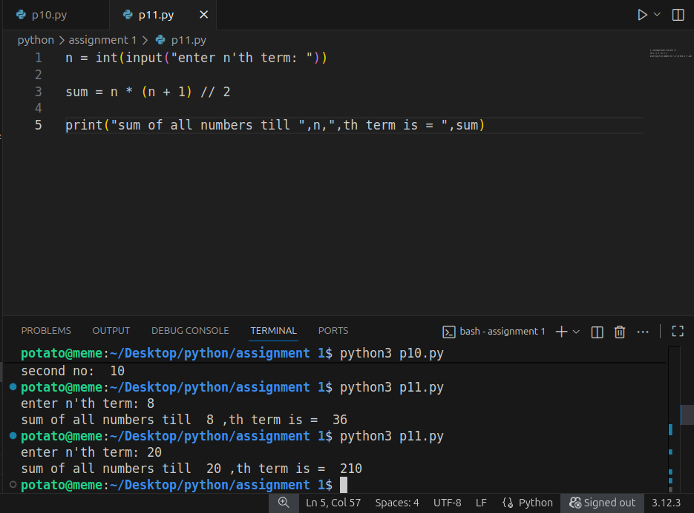
12. Write a program to print truth table for bitwise operators (&, | and ^ operators)
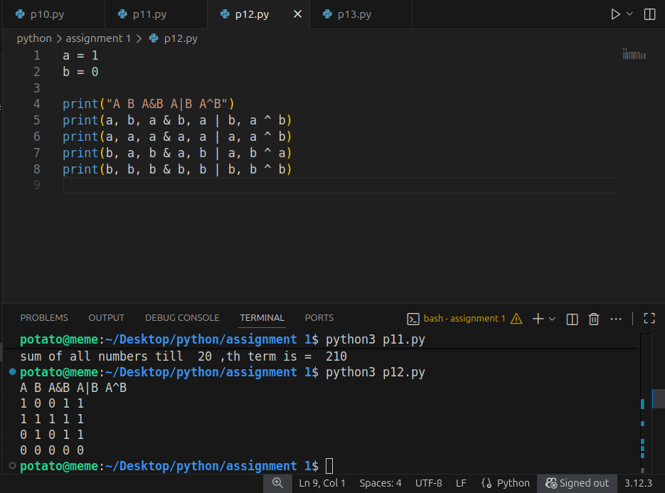
13. Write a program to find left shift and right shift values of a given number.
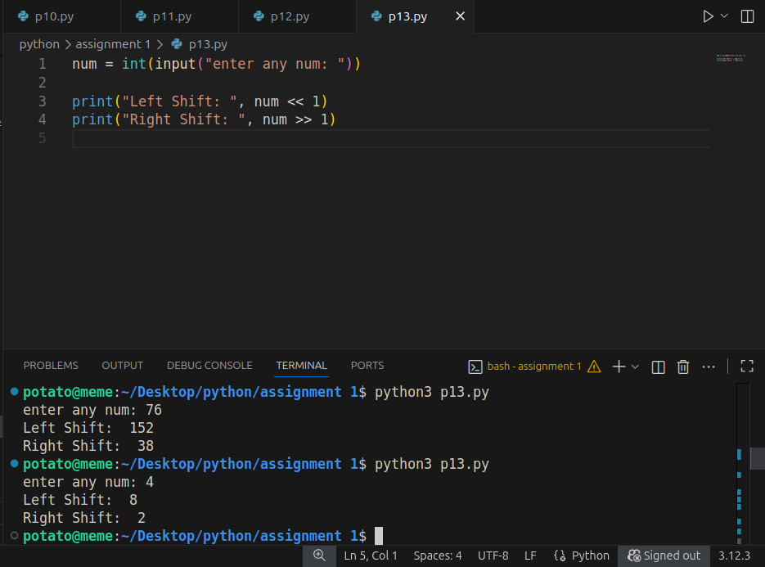
14. Using membership operator find whether a given number is in sequence (10,20,56,78,89)
